**Predict Movie Success**

**Movie project introduction:**

Here we can predict how far the film would be succeeded with certain film features, so we chose the most important features, the most powerful pre-processing techniques and model to get a realistic accuracy.

**Pre-processing Techniques:**

* Dropping any missing data “dropping the data the not have actual value”

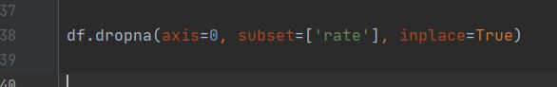

* Choosing the columns of features that affect the output & Transfer string data values into numerical values “fill all nan value with 0 make prepressing on ‘rotten tomatoes’ , ‘directors’”

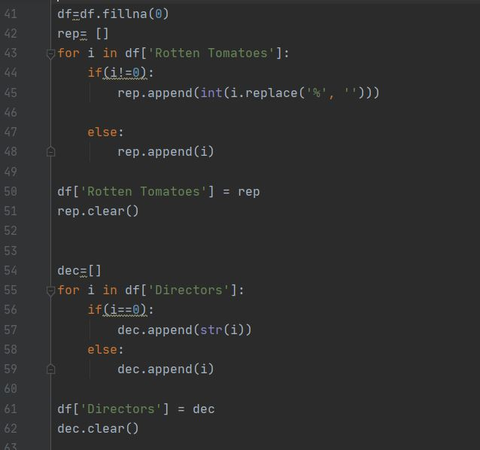

* Choosing the columns of features that affect the output & Transfer string data values into numerical values “transform directors data to numerical values ”

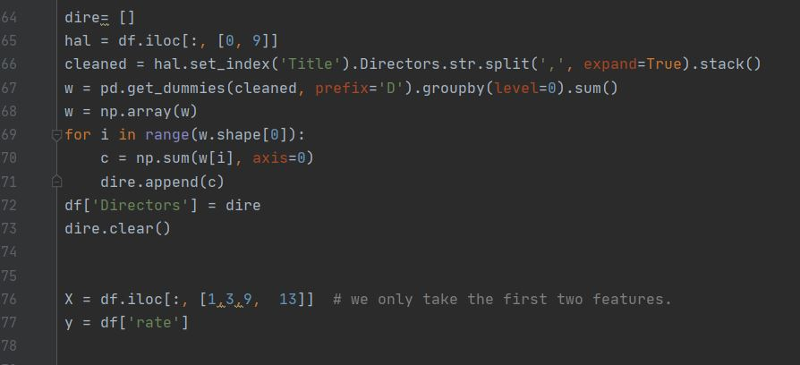

* To split data into training and test sets



* plot data

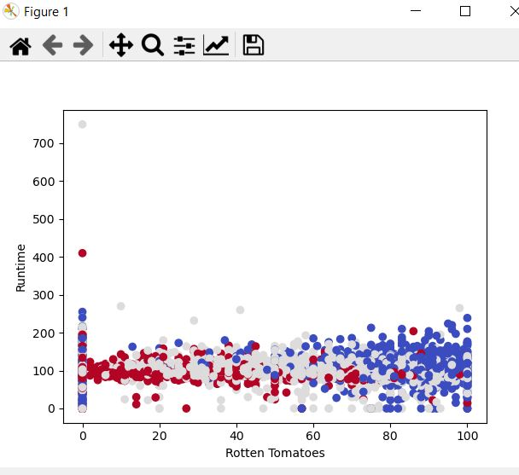

* 3 models used and save and load data

